reverse engineering

**04 – c++ for Reverse engineers**

# Reversing C++ objects

**Lab Description:** Reversing software requires the ability to identify and effectively analyze a wide variety of code constructs and patterns. For this lab, the student is required to reverse engineer a C++ program that uses objects.

**Lab Environment:** IDA Pro Educational

**Lab Files that are Needed:** ReversingCPP.exe.

**Analyze the provided lab file and answer the following questions:**

1. How many objects are created?
2. What is the size of that object/what are the sizes of those objects?
3. Does the first class have a virtual function? Include a screenshot with answer.
4. Does the second class inherit the first class? Include a screenshot with answer.
5. What is Jerry’s number (ID)?
6. What is Bruce’s number (ID)?
7. Is Jerry a base object or a derived object? Include a screenshot with answer.
8. Is Bruce a base object or derived object? Include a screenshot with answer.

## What to submit

Submit a Microsoft Word document or PDF that includes answers to the questions posed along with screenshots demonstrating the installation of the virtual machine.

**1.** There are 2 objects initialized in main.

**2.** The sizes of the objects are 32, and 72.

**3.** It does have a virtual function. You can tell by calls to registers.

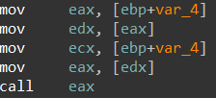

**4.** The second class inherits from the first class.

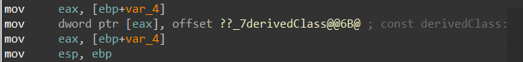**5.** Jerry’s id is 492734.

**6.** Bruce’s id is 923543.

**7.** Jerry is the base object.

